Intrusion detection system in NetSim

The following steps show how a user can run the IDS in NetSim to detect a malicious node, and then setup a new route to the destination avoiding the malicious node

* Creating Malicious nodes for a particular network scenario is explained in Malicious.c file
* To detect the intruder and to send data via a new route, the following files are added in DSR and WLAN:
  + **Pathrater.c** :

This file contains code for avoiding the malicious node and finding a new route (once the IDS detects the malicious node) in networks running DSR in Layer 3. Note that this system would work only for UDP and not for TCP, since TCP involves receiving ack’s from the destination

If _NETSIM_PATHRATER_ is defined, the code is used to validate routes. When the Node is a Malicious Node and a Route Reply is processed, the Function

verifies the route reply in the route cache and checks for the black listed node

i.e.,malicious node. When a malicious node is found, that route entry is deleted from

the cache.

* + **Watchdog.c**

This file contains code for the IDS and is added in WLAN operating in Layer 2.

If _NETSIM_WATCHDOG_ is defined, a watchdog timer starts the moment a packet is sent. Once a packet is forwarded to next hop node, the current node checks for watchdog timer duration if the packet is getting forwarded further on to destination node or not.

The malicious node doesn’t forward packets that it receives. The watchdog timer in the node (which forwarded the packet to the malicious node) expires. A counter is present which measures the number of times the watchdog timer expires (in other words the number of packets sent out but not forwarded by the next hop node). Once this counter’s value reaches cous node) expires.nd then setup a new route to the de/. Once ththe failure threshold the next hope is marked by the current node as a malicious node.

* These updated source files are added in folder DSR and WLAN of the Simulation 8.3.10 IDS folder, which is attached along with.
* Open NetSim.sln from the Simulation 8.3.10 IDS folder in Visual Studio.
* Build DSR followed by WLAN (Check NetSim help-> How to build your Custom Code)

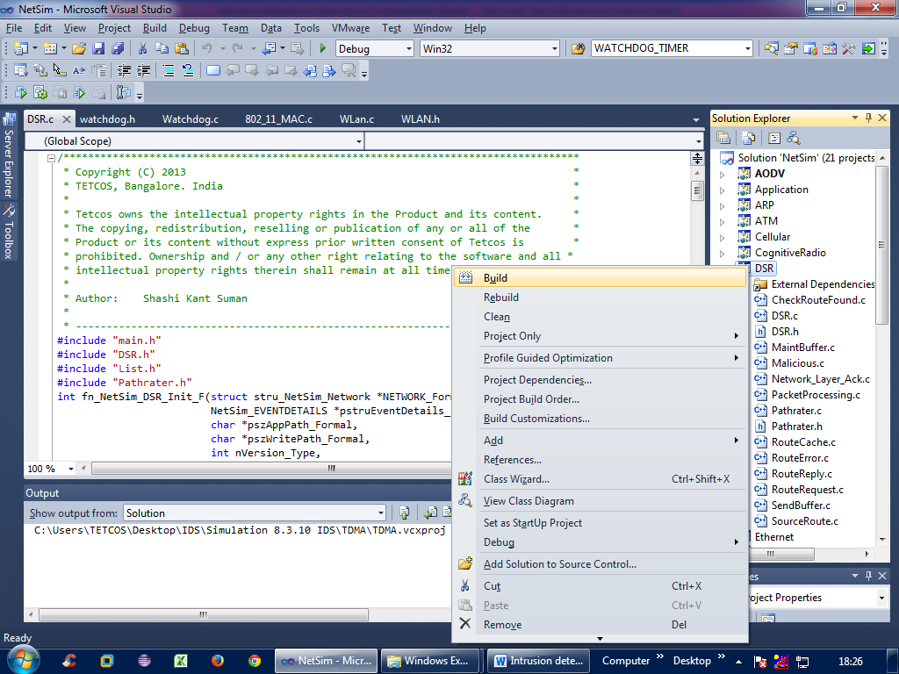

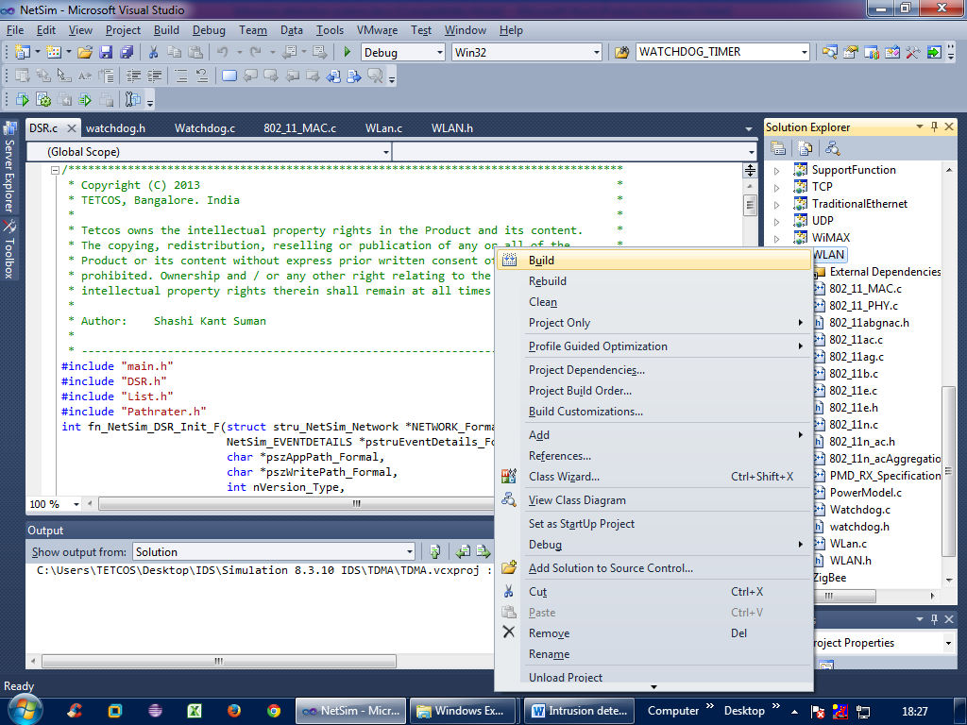

* Copy the dlls in bin folder of NetSim. Take care to rename the original libDSR.dll and libWLAN.dll so as to preserve the original binaries of NetSim

Next, to run the IDS code, follow these steps:

**Step 1:** Create a scenario in NetSim as follows (we have taken an example where node 2 is malicious from time = 0 sec and node 4 from time= 1 sec)

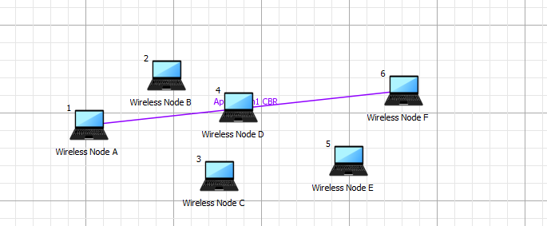

Malicious

**Step 2:** Set the path loss to a fairly high value, to avoid data going directly from source to destination

Example:

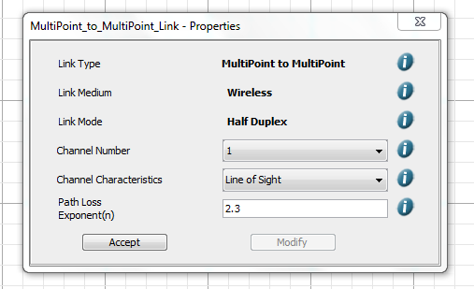

**Step 3:** Set the traffic by clicking and dropping application icon.

Set source and destination as node 1 and node 6.

**Step 4:** Run the simulation

**Step 5:** View packet animation. Here you would notice initially all traffic would flow to the malicious nodes. Per the original code setting the Watchdog timer is set to 2 seconds and the failure threshold is set to 20 packets. So you would notice that around 10.75 seconds and 24.15 seconds, the malicious node is detected and the route to destination would change



Initial flow of packets till node 2 and node 4 are detected as malicious



Flow of packets after node 2 and node 4 are detected as malicious